**Below are the steps, that how you enable accelerated networking on exiting VM.**

**Step1 . Create a NIC variable for your network card.**

PS Azure:\> $nic = Get-AzureRmNetworkInterface -ResourceGroupName rg-csc-entsys-dev-hana -Name amazruseabq3a01584

Azure:/

**Step2 . echo the NIC variable to ensure that you are working on right VM. ( see the lines marked in yellow below in your output.)**

PS Azure:\> echo $nic

Name : amazruseabq3a01584

ResourceGroupName : rg-csc-entsys-dev-hana

Location : eastus

Id : /subscriptions/83b7d931-4059-4f8a-a873-47316b0cb181/resourceGroups/rg-csc-entsys-dev-hana/providers/Microsoft.Network/networkInterfaces/amazruseabq3a01584

Etag : W/"645091b3-ff75-4e68-93e9-c63967d31210"

ResourceGuid : afca041c-7693-4881-9fc6-d2c2169e172e

ProvisioningState : Succeeded

Tags :

VirtualMachine : {

"Id": "/subscriptions/83b7d931-4059-4f8a-a873-47316b0cb181/resourceGroups/rg-csc-entsys-dev-hana/providers/Microsoft.Compute/virtualMachines/AMAZRUSEABQ3A01"

}

IpConfigurations : [

{

"Name": "ipconfig1",

"Etag": "W/\"645091b3-ff75-4e68-93e9-c63967d31210\"",

"Id": "/subscriptions/83b7d931-4059-4f8a-a873-47316b0cb181/resourceGroups/rg-csc-entsys-dev-hana/providers/Microsoft.Network/networkInterfaces/amazruseabq3a01584/ipConfigurations/ipconfig1",

"PrivateIpAllocationMethod": "Dynamic",

"Id": "/subscriptions/83b7d931-4059-4f8a-a873-47316b0cb181/resourceGroups/rg-csc-entsys/providers/Microsoft.Network/virtualNetworks/vnet-entsys-dev/subnets/sn-entsys-dev-sap-usr-priv",

"ResourceNavigationLinks": [],

"ServiceEndpoints": []

},

"ProvisioningState": "Succeeded",

"PrivateIpAddressVersion": "IPv4",

"LoadBalancerBackendAddressPools": [],

"LoadBalancerInboundNatRules": [],

"Primary": true,

"ApplicationGatewayBackendAddressPools": [],

"ApplicationSecurityGroups": []

}

]

DnsSettings : {

"DnsServers": [],

"AppliedDnsServers": []

}

EnableIPForwarding : False

EnableAcceleratedNetworking : False

NetworkSecurityGroup : {

"Id": "/subscriptions/83b7d931-4059-4f8a-a873-47316b0cb181/resourceGroups/rg-csc-entsys-dev-sap/providers/Microsoft.Network/networkSecurityGroups/nsg-entsys-use-dev-sap-usr-priv"

}

**Step3. Enable the Accelerated Networking.**

Azure:/

PS Azure:\> $nic.EnableAcceleratedNetworking = $true

Azure:/

**Step4. Validate the Accelerated Networking is enabled.**

**(See the lines marked in yellow below.)**

PS Azure:\> echo $nic

Name : amazruseabq3a01584

ResourceGroupName : rg-csc-entsys-dev-hana

Location : eastus

Id : /subscriptions/83b7d931-4059-4f8a-a873-47316b0cb181/resourceGroups/rg-csc-entsys-dev-hana/providers/Microsoft.Network/networkInterfaces/amazruseabq3a01584

Etag : W/"645091b3-ff75-4e68-93e9-c63967d31210"

ResourceGuid : afca041c-7693-4881-9fc6-d2c2169e172e

ProvisioningState : Succeeded

Tags :

VirtualMachine : {

"Id": "/subscriptions/83b7d931-4059-4f8a-a873-47316b0cb181/resourceGroups/rg-csc-entsys-dev-hana/providers/Microsoft.Compute/virtualMachines/AMAZRUSEABQ3A01"

}

IpConfigurations : [

{

"Name": "ipconfig1",

"Etag": "W/\"645091b3-ff75-4e68-93e9-c63967d31210\"",

"Id": "/subscriptions/83b7d931-4059-4f8a-a873-47316b0cb181/resourceGroups/rg-csc-entsys-dev-hana/providers/Microsoft.Network/networkInterfaces/amazruseabq3a01584/ipConfigurations/ipconfig1",

"PrivateIpAllocationMethod": "Dynamic",

"Subnet": {

"Id": "/subscriptions/83b7d931-4059-4f8a-a873-47316b0cb181/resourceGroups/rg-csc-entsys/providers/Microsoft.Network/virtualNetworks/vnet-entsys-dev/subnets/sn-entsys-dev-sap-usr-priv",

"ResourceNavigationLinks": [],

"ServiceEndpoints": []

},

"ProvisioningState": "Succeeded",

"PrivateIpAddressVersion": "IPv4",

"LoadBalancerBackendAddressPools": [],

"LoadBalancerInboundNatRules": [],

"Primary": true,

"ApplicationGatewayBackendAddressPools": [],

"ApplicationSecurityGroups": []

}

]

DnsSettings : {

"DnsServers": [],

"AppliedDnsServers": []

}

EnableIPForwarding : False

EnableAcceleratedNetworking : True

NetworkSecurityGroup : {

"Id": "/subscriptions/83b7d931-4059-4f8a-a873-47316b0cb181/resourceGroups/rg-csc-entsys-dev-sap/providers/Microsoft.Network/networkSecurityGroups/nsg-entsys-use-dev-sap-usr-priv"

}

Primary : True

MacAddress :

5. Save the changes.

Azure:/

PS Azure:\> $nic | Set-AzureRmNetworkInterface

Name : amazruseabq3a01584

ResourceGroupName : rg-csc-entsys-dev-hana

Location : eastus

Id : /subscriptions/83b7d931-4059-4f8a-a873-47316b0cb181/resourceGroups/rg-csc-entsys-dev-hana/providers/Microsoft.Network/networkInterfaces/amazruseabq3a01584

Etag : W/"99665ef1-ea62-497e-9a70-3b1596cfb4f0"

ResourceGuid : afca041c-7693-4881-9fc6-d2c2169e172e

ProvisioningState : Succeeded

Tags :

VirtualMachine : {

"Id": "/subscriptions/83b7d931-4059-4f8a-a873-47316b0cb181/resourceGroups/rg-csc-entsys-dev-hana/providers/Microsoft.Compute/virtualMachines/AMAZRUSEABQ3A01"

}

IpConfigurations : [

{

"Name": "ipconfig1",

"Etag": "W/\"99665ef1-ea62-497e-9a70-3b1596cfb4f0\"",

"Id": "/subscriptions/83b7d931-4059-4f8a-a873-47316b0cb181/resourceGroups/rg-csc-entsys-dev-hana/providers/Microsoft.Network/networkInterfaces/amazruseabq3a01584/ipConfigurations/ipconfig1",

"PrivateIpAddress": "10.109.130.37",

"PrivateIpAllocationMethod": "Dynamic",

"Subnet": {

"Id": "/subscriptions/83b7d931-4059-4f8a-a873-47316b0cb181/resourceGroups/rg-csc-entsys/providers/Microsoft.Network/virtualNetworks/vnet-entsys-dev/subnets/sn-entsys-dev-sap-usr-priv",

"ResourceNavigationLinks": [],

"ServiceEndpoints": []

},

"ProvisioningState": "Succeeded",

"PrivateIpAddressVersion": "IPv4",

"LoadBalancerBackendAddressPools": [],

"LoadBalancerInboundNatRules": [],

"Primary": true,

"ApplicationGatewayBackendAddressPools": [],

"ApplicationSecurityGroups": []

}

]

DnsSettings : {

"DnsServers": [],

"AppliedDnsServers": [],

"InternalDomainNameSuffix": "pgtp0c4haquuxhptnhoko3kyzg.bx.internal.cloudapp.net"

}

EnableIPForwarding : False

EnableAcceleratedNetworking : True

NetworkSecurityGroup : {

"Id": "/subscriptions/83b7d931-4059-4f8a-a873-47316b0cb181/resourceGroups/rg-csc-entsys-dev-sap/providers/Microsoft.Network/networkSecurityGroups/nsg-entsys-use-dev-sap-usr-priv"

}

Primary : True

MacAddress :

Azure:/

PS Azure:\>

6. Then I created one more NIC , enabled the Accelerated Networking on it and attached it to the Server Below is screenshot showing Accelerated networking in enabled on Server/NIC.

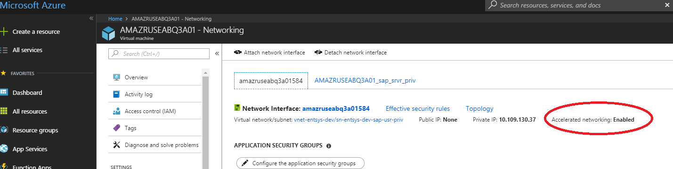

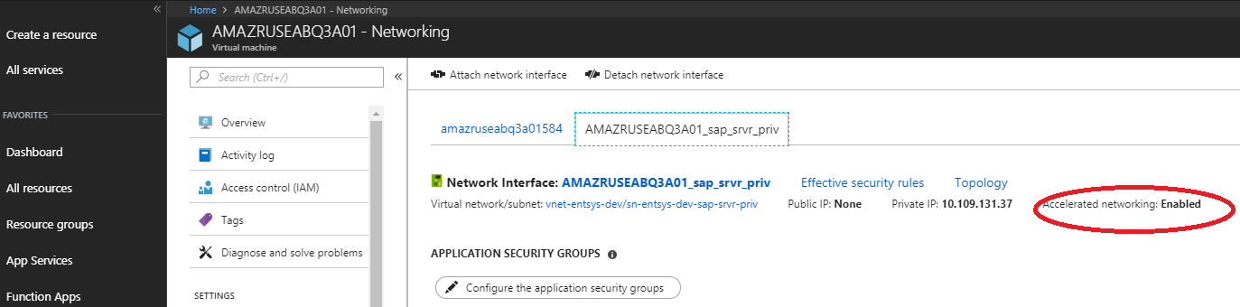

**Note: In - case you struck in this procedure anywhere please drop me email at** [**sunejaa@campbellsoup.com**](mailto:sunejaa@campbellsoup.com)